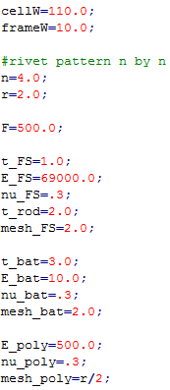These are the important parameters in the ParamModel.py file which can be changed to generate any cell desired. All of these parameters are chosen to build the current 4x4 rivet pattern MES cell.

Notice the n=4. This tells us what rivet pattern we have (4x4).

r=2 is the radius of the rivets

F=500 is the applied force and could be changed to whatever the test state is

The next three groups of numbers are the material properties of the face sheet, battery, and polymer, respectively. As David finds a better approximation for these values they can be changed.

In order to generate this model in abaqus you must run the ParamModel.py script from the file menu. This generates the model according to these parameters and runs a three point bending analysis.

I have run this code and abaqus generates the following model (in 1 minute)

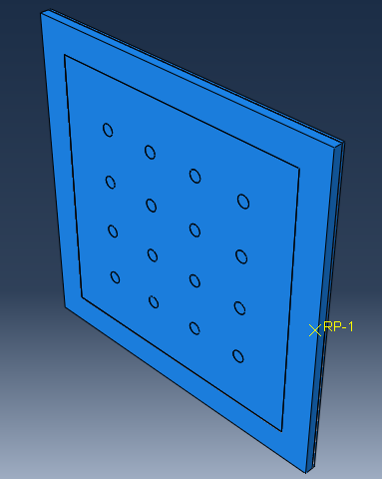

Now say we want to compare this to a 6x6 with 3mm radius rivets and a 5mm frame. All you have to do is change three variables in the code and submit it to abaqus again. Once again this only takes 1 to 2 minutes. Whereas before you would have to go back and completely modify the design.

